**Reflective Essay**

Sangita Neogi

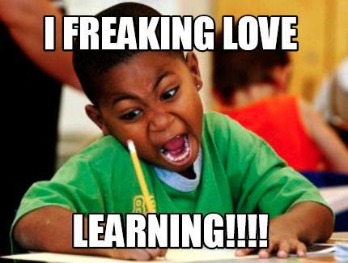

(Image source – Google images)

It is with this energy and dedication that I enter the IDH class every day, driven by the course's undeniable relevance to both my academic and personal growth. The utilitarian value of these classes leaves no room for doubt. Each session serves as a gateway to new terminologies with practical applicability. From Ngram to Capta, terms that I rarely encountered in my prior epistemological involvement with the traditional English literature, expand my understanding of Humanities everyday.

     The first week of the last month has been particularly engaging as we were introduced with an altogether different platform named Slack for interaction, communication and coordination. We explored the *Corpus Thomisticus Project*, a comprehensive collection of works of Saint Thomas Aquinas. Some other projects like *The World of Dante*, which provides a comprehensive multimedia resource for studying Dante's works, particularly the Divine Comedy, within their historical, cultural, and literary contexts or the ***Signs@40*** project that commemorates the 40th anniversary of the journal Signs: Journal of Women in Culture and Society, were introduced. We had some practical engagement with *Timeline JS* too. The class also offered us a comparative analysis between the manual construction of the Oxford English Dictionary and the computer -aided deciphering of the Mayan hieroglyphic script highlighting the growing centrality of computers as an essential tool for all graduate students, regardless of their field of study.

  That session was followed by an exploration of the historical development of Humanities Computing.  This evolution was divided into four historical junctures- the first phase, spanning from 1949 to the early 1970s, is considered the foundational period for the Alliance of Digital Humanities Organizations (ADHO).  The second phase from 1970s-1980s highlighted the need for the Humanities students to learn coding while the third phase, from the mid-1980s to the early 1990s, saw further advancements, leading to the fourth phase, from the early 1990s to the present day, when the internet became an integral part of academic activities.

     The year 1970 was considered as a threshold moment for Digital Humanities as to quote Hockey “this time the need for a methodology for archiving and maintaining electronic texts was fully recognised”. To summarize, those sessions reflected on the shift from Humanities Computing to Digital Humanities. While Humanities Computing solely focused on the computational methods to traditional humanities research, Digital Humanities represented a wide range of digital tools that provided a holistic approach to how technology and humanities interact. Also, the technologies available during the era of Humanities Computing were not as advancing as in the DH era that democratized the field with more powerful and accessible computing. But it doesn’t mean that Digital Humanities was replacing Humanities Computing, rather it brought up a new dimension to it by expanding its scope, methodology and impact. This new dimension makes the humanities more dynamic, accessible and relevant in the digital age.

Recent sessions are focusing on data, its nature, classifications such as Big Data and Small Data. We are gaining insights into how the data considered by Digital Humanities as text differs from the traditional data used in the humanities emphasizing the transformative impact of the ‘digital’ revolution. Last but not the least Professor Shanmuga Priya also arranged a seminar on E Literature where Samya Brata Roy, a PhD scholar was invited to share some interesting insights on this budding arena. The seminar was an added bonus to my ‘freaking love’ for learning.

Works Cited

**Hockey, Susan.** "The History of Humanities Computing." A Companion to Digital Humanities, edited by Susan Schreibman, Ray Siemens, and John Unsworth, Blackwell, 2004